Assignment 3
Jackson Wiebe
3519635
Answer all questions – maximum 100 marks. You must score at least 50 to pass the assignment.
- (5 marks) Illustrate that the nodes of any AVL tree T can be colored “red” and “black” so that T becomes a red-black tree.
For a valid red-black tree we must satisfy the following conditions:
- A node can only be red or black
- The root and leaf nodes are always black
- If a node is red, its children are inserted as black
- All paths from a given node to its leaves must contain the same number of black nodes

For a valid AVL tree we have a similar, but stricter rule:
- The height difference of the left and right subtrees for any given node can not exceed 2

Since an AVL tree is more strictly balanced it should be possible to always convert an AVL tree to a red-black tree. The given example satisfies all of the conditions for both red-black and AVL .
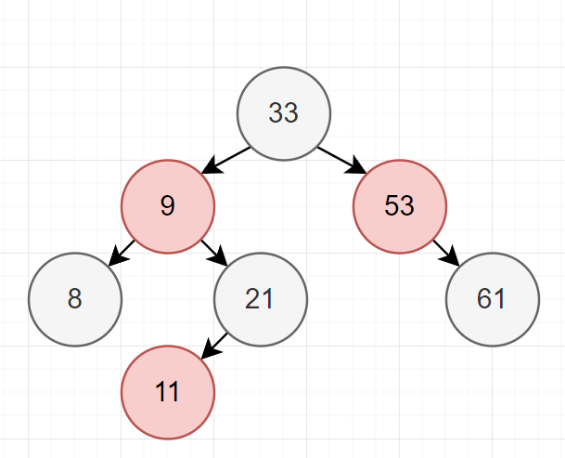

- (5 + 10 = 15 marks) Illustrate that via AVL single rotation, any binary search tree T1 can be transformed into another search tree T2 (with the same items) (5 marks).
Give an algorithm to perform this transformation using O(N log N) rotation on average (10 marks).
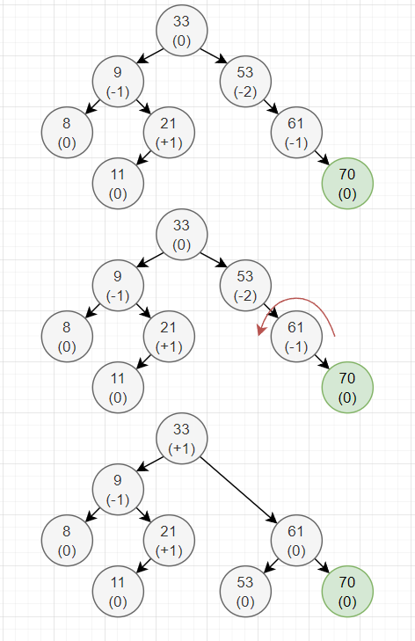
Using the previous tree we want to insert a new node with a value of 70. This will unbalance the tree as can be at the #53 node the height has been become unbalanced by a factor equal to two. To correct this with a single rotation we perform a left rotation about the 61 node.
public void balenceCheck(Node target) {
int balance = target.parent.balance;
if (balance < 2 && balance > -2) {
// If the subtrees of the parent node are balanced we are done
return;
} else if (target.heightBalence == 2) {
RRotation(target);
} else if (target.heightBalence == -2) {
LLrotation(target);
}
// Check the parent for balance
balenceCheck(target.head);
}

public void LLrotation(node target){
//Move the parent node into our left child
target.left = target.parent;
//Change the pointer of left's parent to this node.
target.left.parent.right = target;
//clear lefts pointer
target.left.right = null;
return;
}

- (10 + 2 = 12 marks) Suppose you are given two sequences S1 and S2 of n elements, possibly containing duplicates, on which a total order relation is defined. Describe an efficient algorithm for determining if S1 and S2 contain the same set of elements (10 marks).
Analyze the running time of this method (2 marks).
For this function I have chosen to iterate through S1 and look for a match in S2. Upon finding a match we remove the object from both sets. If both sets contain the same set of elements the resulting lists will both be empty.
public boolean sameSet(ArrayList<Object> set1, ArrayList<Object> set2) {
//for each object in set 1
for (Object var : set1) {
//If set 2 contains the same object
if (set2.contains(var)) {
//Remove that object from each set
set1.remove(var);
set2.remove(var);
}
}
//After itterating through all of set 1. If both sets are empty then matches were found in both sets
return set1.isEmpty() && set2.isEmpty();
}

The resulting complexity for this function is O(n²). This is because in a worst case scenario each object in S1 will need to be compare with every element in S2.

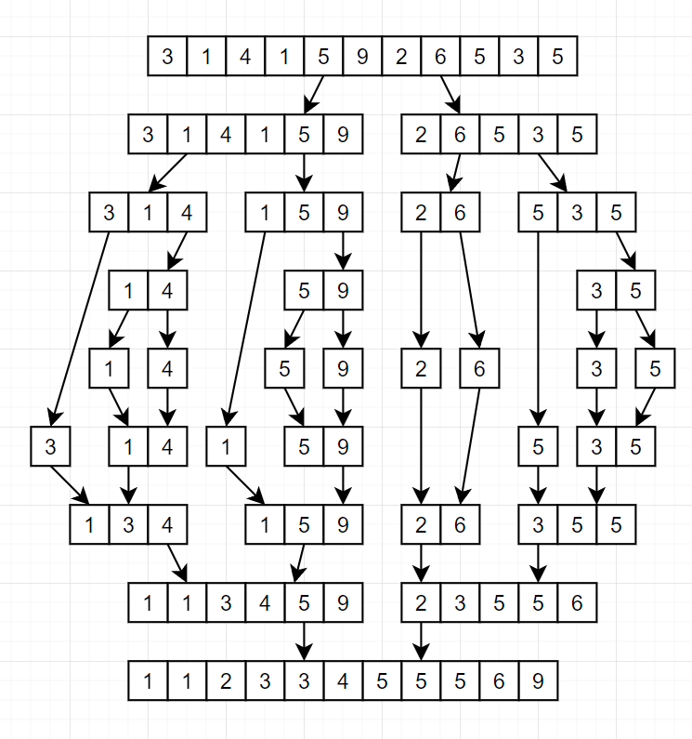
- (5 + 8 = 13 marks) Given sequence 3, 1, 4, 1, 5, 9, 2, 6, 5, 3, 5, sort the sequence using the following algorithms, and illustrate the details of the execution of the algorithms:
  - (5 marks) merge-sort algorithm.
For merge sort we continually split the array at the middle element until we have each element split out. Then we can recursively combine those elements in the correct order.

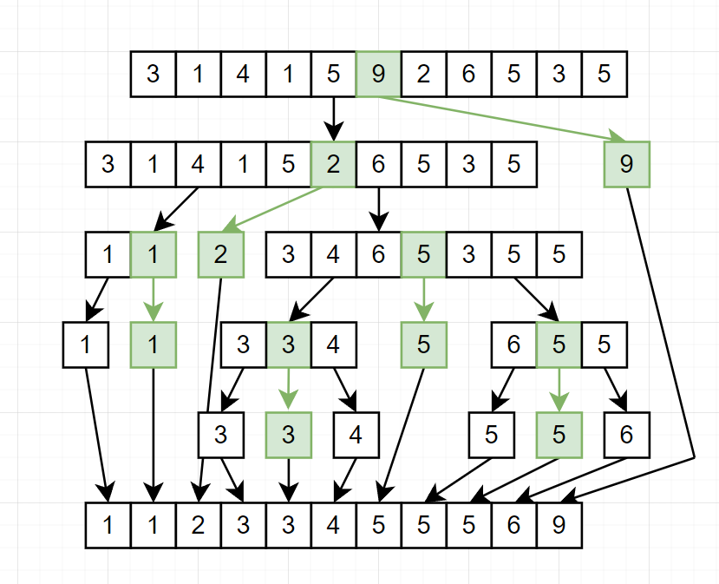
  - (8 marks) quick-sort algorithm. Choose a partitioning strategy you like to pick a pivot element from the sequence. Analyze how different portioning strategies may impact on the performance of the sorting algorithm.
For quick sort we pull the middle number of an array as the pivot point. Shown in Green. We then create 2 sub arrays if they are higher or lower than the chosen pivot. Once all the sub array are less than 2 we can merge the result back into a sorted list.
The selection of the pivot point will drastically change the performance of the sorting as it relates to the resulting number of sub arrays. Ideal if we can ensure each quick sort results in 2 sub arrays our pivot point was an ideal selection. Otherwise we may be calling quicksort more often than needed.
Other options for pivot points include Left, Right, Middle, Median, Random, etc.

- (4 + 4 + 7 + 10 = 25 marks) Given the graph shown below, answer the following questions:
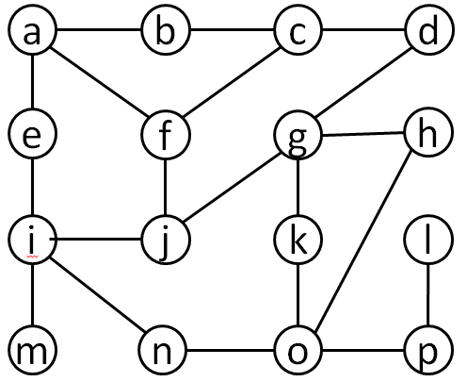
  - (4 marks) Illustrate the sequence of vertices of this graph visited using depth-first search traversal starting at vertex g.
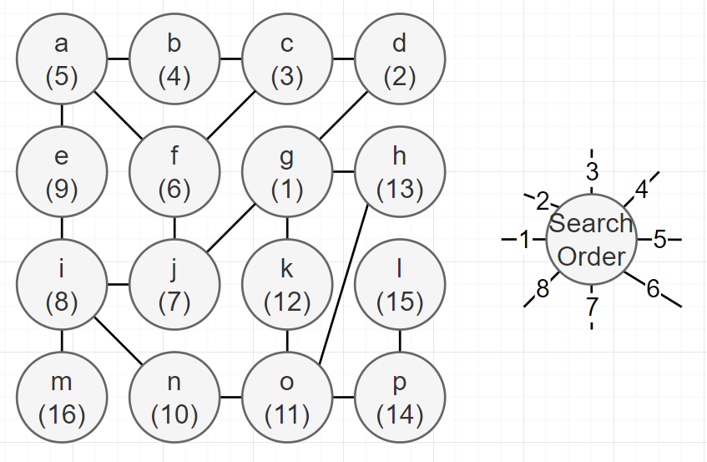
  - (4 marks) Illustrate the sequence of vertices of this graph visited using breadth-first search traversal starting at vertex b.
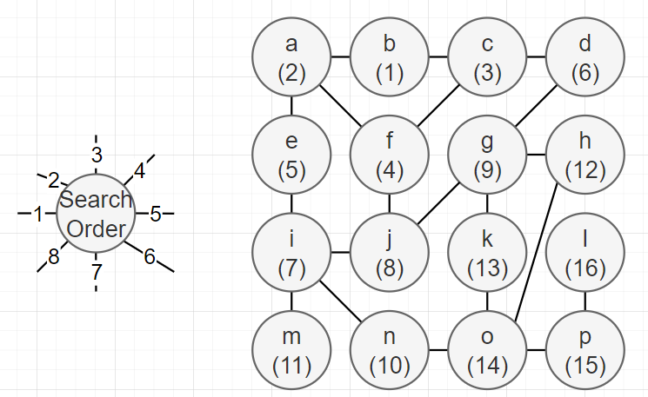

  - (7 marks) Illustrate adjacency list representation and adjacency matrix representation, respectively, for this graph. What are the advantages and disadvantages of those two representations?
Adjacency List. Great at showing the breadth first connections. Quick to find all the edge cases or alienated node. Can use more memory to use.
a | b | c | d | e | f | g | h | i | j | k | l | m | n | o | p
b | a | b | g | a | a | d | g | e | i | g | p | i | i | n | i
e | c | d | c | i | c | h | o | j | f | o |  |  | o | k | o
f |  | f |  |  | j | k |  | n | g |  |  |  |  | h
 |  |  |  |  |  | j |  | m |  |  |  |  |  | p

Adjacency Matrix. Uses more memory than a list, Faster to find a specific edge. Slow to add and delete.
 | a | b | c | d | e | f | g | h | i | j | k | l | m | n | o | p
a | 0 | 1 | 0 | 0 | 1 | 1 | 0 | 0 | 0 | 0 | 0 | 0 | 0 | 0 | 0 | 0
b | 1 | 0 | 1 | 0 | 0 | 0 | 0 | 0 | 0 | 0 | 0 | 0 | 0 | 0 | 0 | 0
c | 0 | 1 | 0 | 1 | 0 | 1 | 0 | 0 | 0 | 0 | 0 | 0 | 0 | 0 | 0 | 0
d | 0 | 0 | 1 | 0 | 0 | 0 | 1 | 0 | 0 | 0 | 0 | 0 | 0 | 0 | 0 | 0
e | 1 | 0 | 0 | 0 | 0 | 0 | 0 | 0 | 1 | 0 | 0 | 0 | 0 | 0 | 0 | 0
f | 1 | 0 | 0 | 0 | 0 | 0 | 0 | 0 | 0 | 1 | 0 | 0 | 0 | 0 | 0 | 0
g | 0 | 0 | 0 | 1 | 0 | 0 | 1 | 1 | 0 | 1 | 1 | 0 | 0 | 0 | 0 | 0
h | 0 | 0 | 0 | 0 | 0 | 0 | 1 | 0 | 0 | 0 | 0 | 0 | 0 | 0 | 0 | 0
i | 0 | 0 | 0 | 0 | 1 | 0 | 0 | 0 | 0 | 1 | 0 | 0 | 1 | 1 | 0 | 0
j | 0 | 0 | 0 | 0 | 0 | 1 | 0 | 0 | 1 | 0 | 0 | 0 | 0 | 0 | 0 | 0
k | 0 | 0 | 0 | 0 | 0 | 0 | 1 | 0 | 0 | 0 | 0 | 0 | 0 | 0 | 1 | 0
l | 0 | 0 | 0 | 0 | 0 | 0 | 0 | 0 | 0 | 0 | 0 | 0 | 0 | 0 | 0 | 1
m | 0 | 0 | 0 | 0 | 0 | 0 | 0 | 0 | 1 | 0 | 0 | 0 | 0 | 0 | 0 | 0
n | 0 | 0 | 0 | 0 | 0 | 0 | 0 | 0 | 0 | 0 | 0 | 0 | 0 | 0 | 1 | 0
o | 0 | 0 | 0 | 0 | 0 | 0 | 0 | 1 | 0 | 0 | 1 | 0 | 0 | 1 | 0 | 1
p | 0 | 0 | 0 | 0 | 0 | 0 | 0 | 0 | 0 | 0 | 0 | 1 | 0 | 0 | 1 | 0

  - (10 marks) Describe an algorithm to find in the graph a path illustrated below that goes through every edge exactly once in each direction.

This is known as Eulerian Path. The intent here is to build a list of traversals that hits every edge only once. What I would is represent this as a queue of edges. Starting from any node we recursively traverse that nodes links in such a way that we are not removed from the rest of the graph until there are no edges remaining.

The sudo code for this would be something similar to:
For each start node:
Create a Queue of paths travelled
While ( !Eulerian Path Found or No Path Remains):
Do a Depth First search for paths untravelled.
Add path to queue and start new DFS
If we are stuck, Dequeue last path and start DFS

- (10 marks) Exercise 9.7. Why does the method remove(x) in the RedBlackTree implementation perform the assignment u:parent = w:parent? Shouldn’t this already be done by the call to splice(w)?
The purpose of that assigned appears to be mostly cleanup. To ensure the w.parent link is not left dangling. The removal operation in a RB tree is to find a node with only one child and splice w out of the tree with its child.

- (10 marks) Exercise 10.8. Implement the remove(u) method, that removes the node u from a MeldableHeap. This method should run in O(log n) expected time.
public int remove()
{
int x = root.x;
//Meld the 2 subtrees into 1, assign to root
root = meld(root.left, root.right);
n--; //number of nodes reduced
return x;
}

public Node meld(Node n1, Node n2)
{
//If tree only has 1 child
if (n1 == null)
return n2;
if (n2 == null)
return n1;

//If the left tree is greater than the right we meld lower down
if (n2.x < n1.x)
return meld(n2, n1);

//randomly meld the tree
if (rand.nextBoolean())
{
n1.left = meld(n1.left, n2);
n1.left.parent = n1;
}
else
{
n1.right = meld(n1.right, n2);
n1.right.parent = n1;
}
//return new node
return n1;
}

- (10 marks) Exercise 11.12. Prove that a binary tree with k leaves has height at least log k.
From page 133 in the text, a node is a leaf if it has no children.
We know that, for a height of 0, we have 1 node, which is also a leaf. Log(1) = 0. Correct.
Height | Number of leaves
0 | 1
1 | 2
2 | 4
3 | 8

Since each node can only have 2 leaves and only a node without children is a leaf. The number of leaves will grow at an exponential rate as defined: number of leaves k, = 2^h. Where h represents the height. We can invert that formula such that h = log(k)

